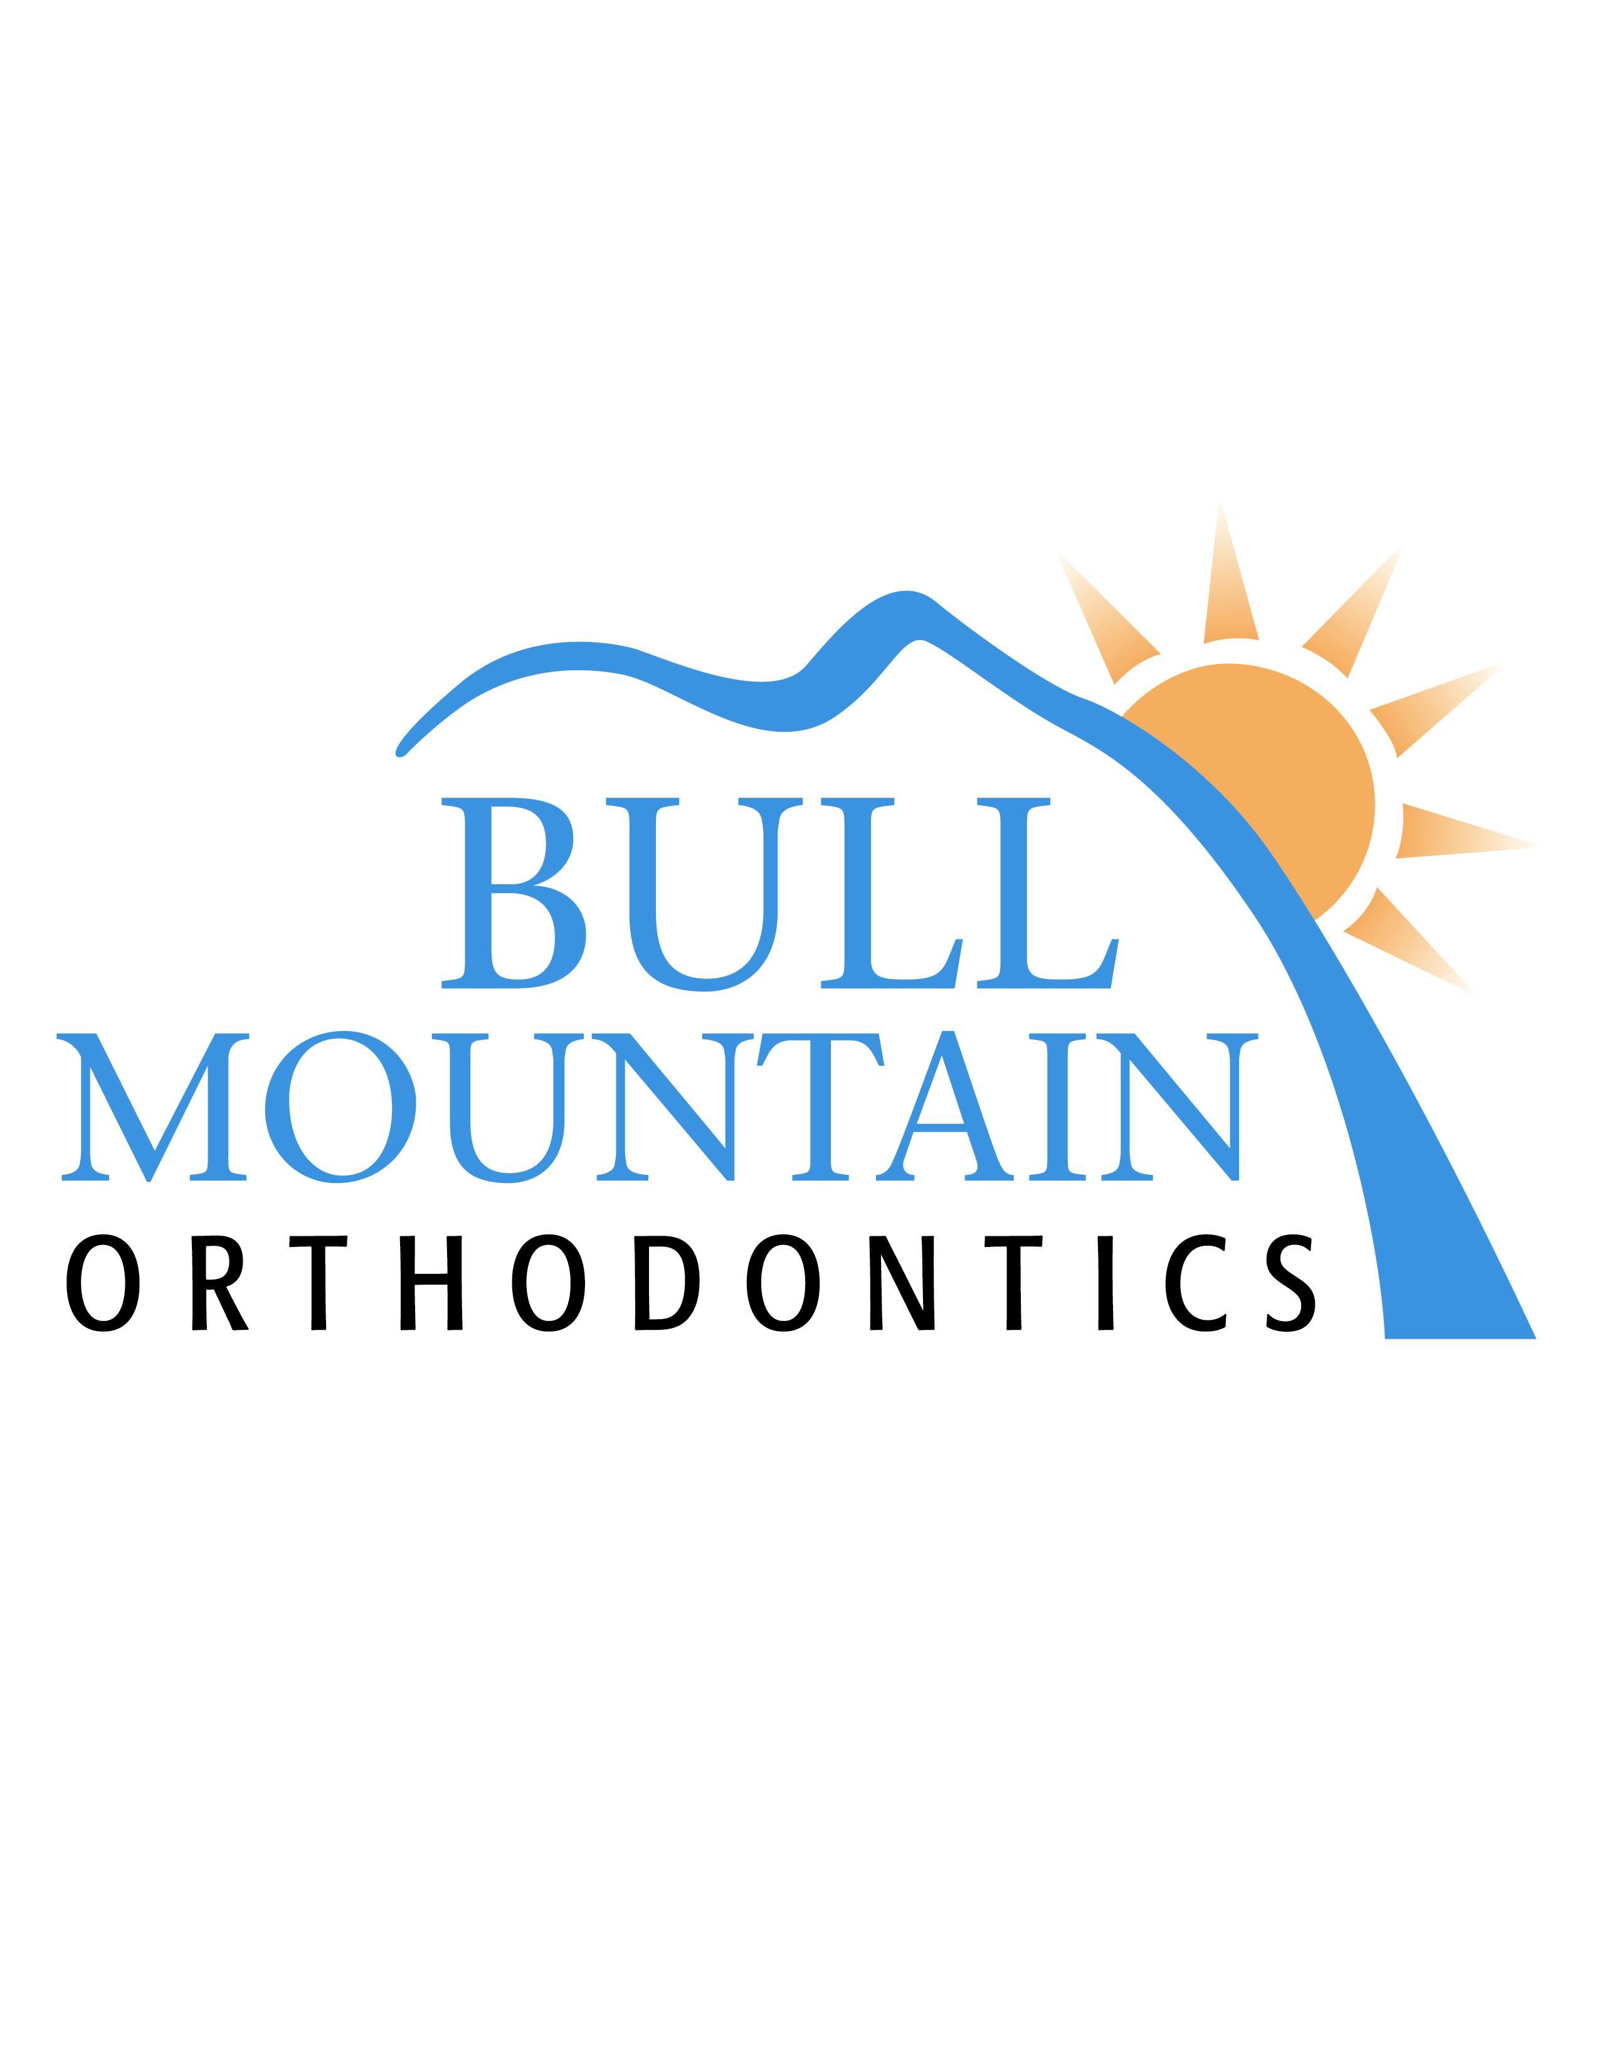
A B C
Patient Information
Patient’s name____________________________________________________ Preferred Name ___________________
Last First Middle
Address
Street City Zip
Home Phone______________________ Email _________________________ Birth date ______________ Age _______

Whom may we thank for referring you to our office?________________________________________________________

What concerns you most about your teeth?

Please list some hobbies or interests

Responsible Party Information
Name Relationship to Patient
Last First Middle
Address
Street City Zip
How long at this address?______ Home phone_________________________ Work phone
Previous Address (If less than 3 years)
Employer_____________________________________ Occupation____________________ No. years employed
Birthdate_____________ Email Married / Single / Divorced (Please circle one)
Spouse’s Name___________________________________________________Relationship to Patient
Address if different than Patient
Employer__________________________________Occupation____________________ No. years employed
Birthdate Work Phone Email

Dental Insurance Information
Insured’s Name____________________________________ Insured’s SSN or ID #
Dental Insurance Company_________________________ Group No._________________ Birth date
Insurance Co. Address_________________________________________________ Phone No.
If you have dual dental insurance coverage, please enter the following information about the other plan:
Insured’s Name____________________________________Insured’s SSN or ID #
Dental Insurance Company_________________________ Group No._________________ Birth date
Insurance Co. Address_________________________________________________ Phone No.

Emergency Information
Name of nearest relative not living with you
Complete address
Street City Zip
Phone

I understand that where appropriate, credit bureau reports may be obtained.
Signature (Parent’s signature if minor)____________________________________________Date _________________

MEDICAL HISTORY

Physician Date of Last Visit
Address Phone
Please circle Yes or No (If Yes, please fill in details)
Yes No Are you taking any medication?
Yes No Do you have any allergies?
Yes No Do you have a history of a major illness?
Yes No Have you had any major operations?
Yes No Have you ever been involved in a serious accident?
Circle any of the medical conditions below that you have had or currently have.
Arthritis Diabetes Hepatitis/Liver problems Metal Allergies
Artificial joints Dizziness Herpes Nervous Disorders
Asthma or Hay-fever Epilepsy High Blood Pressure Radiation/Chemotherapy
Blood or bleeding disorders Gastrointestinal Disorders HIV / Aids Rheumatic Fever
Bone Disorders Growth Disorders Kidney problems Tuberculosis
Congenital Heart Defect Heart Problems or Murmur Latex Allergy Tumor or Cancer
Are there any medical conditions we have not discussed that you feel we should be aware of or additional information you feel may be helpful?

DENTAL HISTORY

Dentist Date of last exam & cleaning
Any restorative work remaining to be done? _______________________________________________________

Yes No Do you take antibiotics before your dental visits?
Yes No Are you presently in any dental pain?
Yes No Have there been any injuries to face, mouth or teeth?
Yes No Is any part of your mouth sensitive to temperature or pressure?
Yes No Do your gums bleed when you brush?
Yes No Do you have any type of thumb, tongue or lip habit?
Yes No Are you a mouth breather?
Yes No Have you ever seen an orthodontist? If yes, who and when?
Yes No Would you object to wearing orthodontic appliances (braces) should they be indicated?
Yes No Has anyone in your family received orthodontic treatment? How did they feel about the result? What is your attitude toward receiving orthodontic treatment?
Yes No Do your teeth or jaws ever feel uncomfortable when you awake in the morning?
Yes No Are you aware of your jaw clicking or popping?
Yes No Are you aware of clenching your teeth during the day?
Yes No Have you ever been told that you grind your teeth?
Yes No Do you have “tension” headaches?
Yes No If the patient is under age 16, approximate height of parents? Mom______ Dad______
Yes No Are you aware that some appointments will need to be during school/work hours?
Female Patients only
Yes No Are you pregnant?
Yes No Has menstruation started? If so, when? (tells us about growth remaining)

Orthodontics is a service that provides an improvement in the general function, health and appearance of the teeth. As with any treatment, some risks are involved. Teeth, gums and jaws are an intricate body part and may not respond to treatment. If good oral hygiene is not practiced, tooth decay and enlarged gums can result. Joint discomfort and root shortening may occur in a small percentage of cases. Teeth change throughout our lifetime and there can be some movement of teeth and the jaws after treatment. I have truthfully answered all the above questions and agree to inform this office of any changes in my personal, medical or dental history. In addition, I authorize Bull Mountain Orthodontics, its doctors and staff to perform a complete orthodontic evaluation including radiographs (x-rays), photos and impressions (molds) of the patient’s teeth. I have read and understand this paragraph; I also understand that my diagnostic records may be used for educational and promotional purposes.
Signature (Parent’s signature if minor)____________________________________________Date _________________

